Biosensors - week #3 Volvuino - Julien Pichon, Sarah Talon Sampieri, Clément Caporal

Protocol

___________________________________________________________________________________________________________

Look at the [Design Plan](https://docs.google.com/presentation/d/1lO26NH6yMm-VOvK3STqGF0lz-ubTobzk9kmKnZmGvEw/edit?usp=sharing) to have more detailed information on the protocol

Look also at our [Protocol video](https://youtu.be/OKXiIRd8ePY) on youtube to remake the experiment by yourself!

___________________________________________________________________________________________________________

* **Preliminary tests**
* **Detailed protocol**
* **Salt gradient**
* **The setup**
* **Data measurement and analysis method**

___________________________________________________________________________________________________________

Monday 6th February

* **Preliminary tests:**

**Test of visibility of volvox:**

Binocular loupes: we can see the *Volvox* moving, movement seems random. But they move. And the slides have a good size.

Water: tap water. They stop after a while. Need more information from our mentors on the better water to use.

**Test of medium**

Try dechlorinated tap water (*Volvox* stopped to move after around 5 minutes, in tap water).

**Test of directed light**

They do not seem to change that much by changing in in dark room with iphone light. They move quite similarly. Maybe the intensity is too strong or not enough direct? We asked our mentors on high intensities resistances of *Volvox*.

**Test of lens**

As we cannot mix up white light with blue light (we need only a source of light for phototaxis) but we still need the light of the microscope to observe the movement of *Volvox* in their phototaxis, we decided to use a lens which filter the white light: we know by bibliography that *Volvox* are very sensitive to blue-cyan light and green light, to which they proceed photosynthesis. We then decided to test out a red lens

Tuesday 7th February

**Detailed protocol**

* **Materials**:

Mother culture with *Volvox aureus*

10 cell slides

Binocular loupes

1 blue light led

1 arduino

1 filter for of 530 wavelength

One resistance

Pieces of wood to hold the blue light

One paper box to cover the microscope

7 eppendorf

1 mL of still water

1 g of NaCl (salt)

Pipettes for 200 microliter

Cover slides (around )

Wooden box for the arduino

* **Salt gradient**

In literature, we found out that *Volvox* could thrive till the salinity of 0.18 g/mL. For this reason, we decided that our maximal value of concentration will be around this value.

We then decide to prepare our solution of salt and water in 7 different eppendorf. One for the negative control (no salt), one for the positive control (the maximal value of salt) and the 5 values of salt in between the positive and negative control.

We found out in literature[1] that saturation gradient of salt in water depends on temperature, and that around 20° one milliliter of water can dissolve around **0.357 g** of salt. This is why we cannot overcome this quantity of salt in the mother culture of salt and water.

Preparation of mother culture of salt and water:

* we put 3 g of salt in 10 mL of water (0.3 g/microL).
* Vortex the tube till all the salt is saturated

Dilutions in Eppendorfs:

The mother culture has the maximal concentration possible of salt and water. The concentrations we decide to have for the replicates are: **0.1** (positive control), **0.08**, **0.07**, **0.06**, **0.03**, **0.01**, **no salt** (negative control).

* Use a pipet to dilute
* Each eppendorf has **200 microL** of solution: we calculated that each well of our slide plates can contain around 60 microL. We measured that by pipetting and see how much how much water each well could contain.
* We adjusted each eppendorf to 200 microL by adding **still water**: thanks to our mentors, we found out still water was a better medium to study *Volvox* motility.
* From the mother culture, take 200 microL and put it in the 0.1 concentration.
* 0.08: From the mother culture, take 160 microL of mother culture and put it in the second eppendorf: adjust to 200 microL with 40 microL of still water.
* 0.07: From the mother culture, take 140 microL and adjust with 60 microL of water.
* 0.06: From the mother culture, take 120 microL and adjust with 80 microL of water.
* 0.03: From the mother culture, take 60 microL and adjust with 140 microL of water.
* 0.01: From the mother culture, take 10 microL and adjust with 180 microL of water.
* Negative control: but 200 microL of still water in a eppendorf without salt.

Our first plan was to have 600 microL of solution in each eppendorf (200 of salt + water and 400 from mother culture), but we then realized that we couldn’t mix them suddenly as measurements on wells would have been done one by one, and there was the time bias.

For this reason, we decide to put in each well, **at the time of the experiment**, 40 microL of the colony from its mother culture and 20 mL of the salinity gradient we want to study.

Each measurement is done one by one:

- we put the colony

- the solution with salt

- these first two steps take around 1 minute - we record the video for 1 minute

- we stop and label the video to be measured

For each salinity gradient, we do around **2 replicates**.

For the positive and negative controls, we also do **2 replicates**.

Replicates are the wells used with the same salt gradient and culture media of *Volvox*.

**Note**: Each well does not contain the same number of volvox: we cannot control this sample size “bias” as we cannot be use of taking a certain amount of *Volvox* by pipetting, but the very parameter we need to pay attention at is the salinity gradient: it has to be constant for each replicate, so we have to take the same quantity of mother culture (40 microL par well) for each replicate.

After having taken the analysis for the the concentration of 0.3 g/mL, we suddenly found out that the *Volvox* stopped to move: this does not necessarily mean they are dead, but we decided to change our range of salinity to quantify possibly more movement of the colony.

Mother solution :

* Put 10mL of distilled water in a Utube
* Add 3g of NaCl
* Vortex at 3000rpm during 20seconds

Prepare the eppendorf :

|  |  |  |
| --- | --- | --- |
| Concentration (g/ml) | Mother Solution (microlitre) | Distilled water (microlitre) |
| 0 | 0 | 200 |
| 0.003 | 2 | 198 |
| 0.005 | 3.3 | 196.7 |
| 0.008 | 5.3 | 194.7 |
| 0.01 | 6.6 | 193.4 |
| 0.03 | 20 | 180 |

Then vortex at 3000 rpm during 20s

Use the same method of the one mentioned above to prepare again the new concentrations with salt and water. And then, start the analysis under the microscope again.

The lens we used was for **red light**: we knew by literature (thanks to our mentor) that this is usually the filter used by researchers to study *Volvox* phototaxis, as *Volvox* are less sensitive to it rather than to the other wavelengths.

Wednesday 8th February

**Repetitions of the experiment:**

The all experiment has been repeated at the laboratory: each salt concentration has been prepared again and each data collection has been done.

Start of data analysis (see below for details)

**Errors/Remarks during the experiments:**

* In the wells, there were some bubbles sometimes created by air.
* 60 microL of solution was maybe not enough: and also, water was escaping from the bottom as the well was not really well closed: water flowed in the other wells.
* Not exactly 1 minute time of preparation for each experiment
* Not same intensity of light between the two days of experiment
* Not the same light of exposure when the *Volvox* were put back on the table.

**The setup**

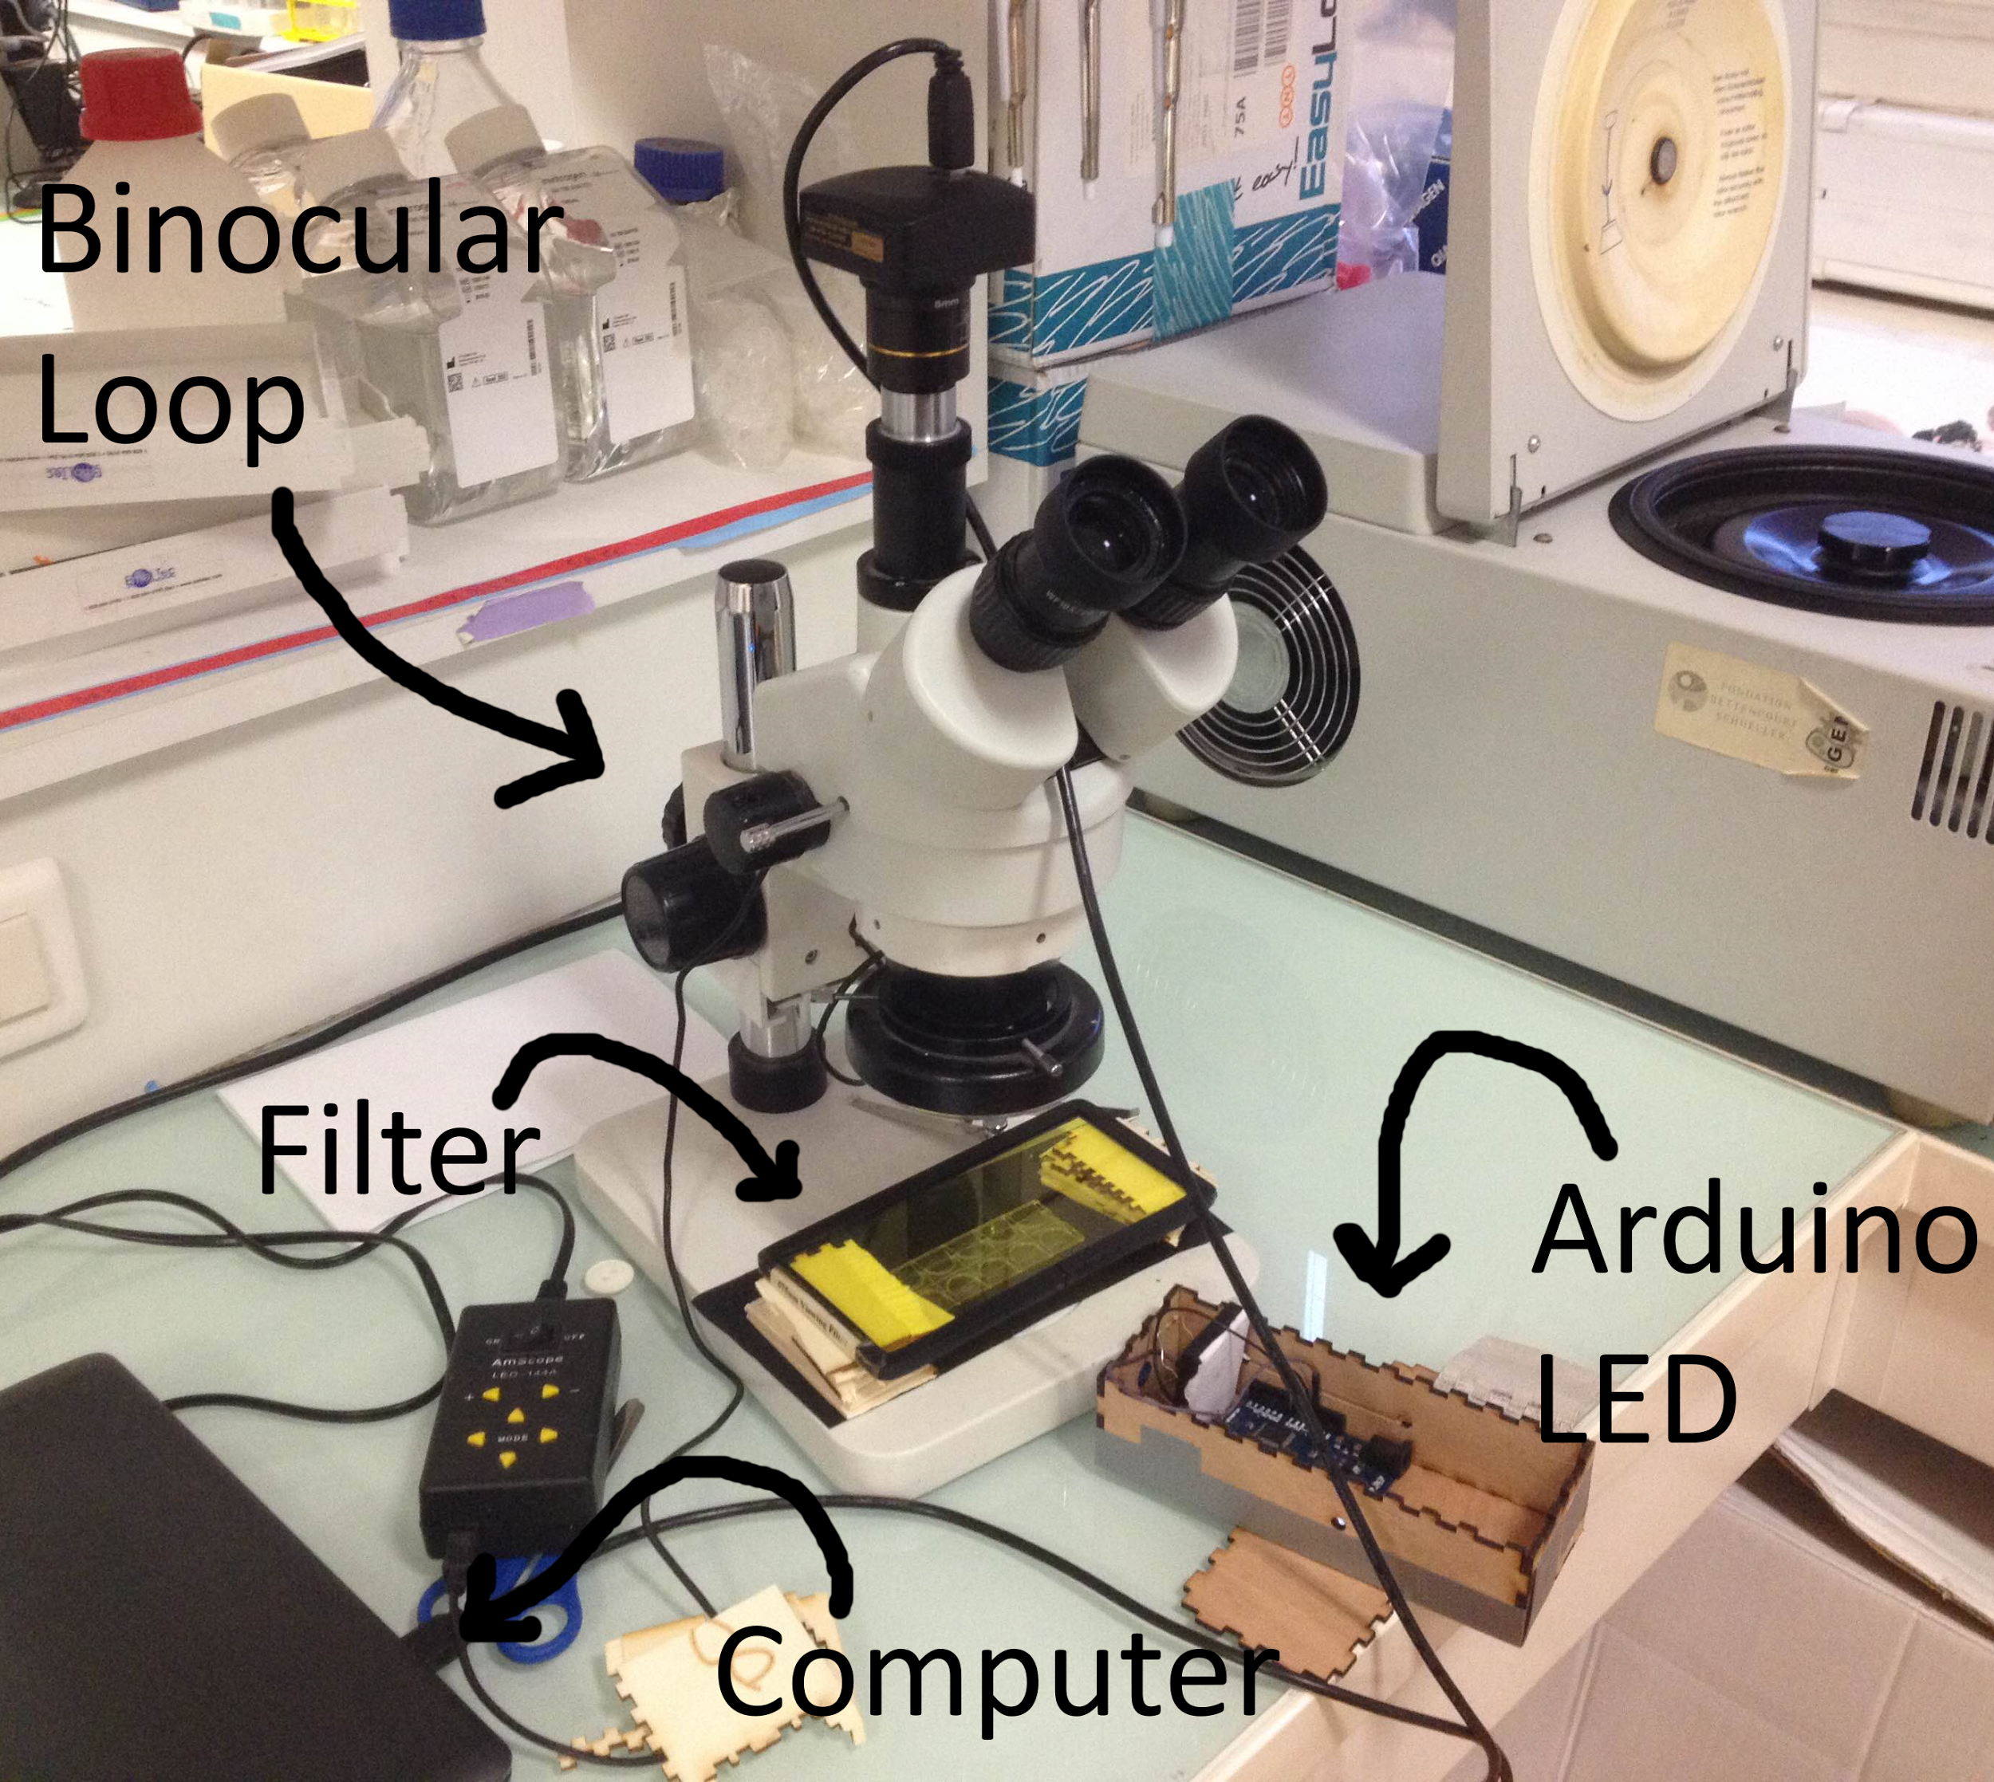

For the setup, we decided to use  **binocular loupes**: the zoom in wasn’t that big and allowed us to observe the movement of several *Volvo*x in the same area*.* (one Volvox colony diameter is around 100 - 6 000 microns ).

Up to area on which we put the samples, there is a strong white light: to minimize the effect of its different wavelengths, we decided to put a red filter to let only the red light passing through the colony.

On one side, we put the blue led light in the arduino, which is itself contained in a box, scotched to be a fixed and constant light.

Under the objective, there is the set of 10 little wells: in the objective of the microscope we can observe one well.

Up to the microscope there is a camera which is linked to a computer.

We cover the microscope with a paper box, to avoid environment light affecting our experiments: even if wa cannot manage to completely not have light from the room, this setup is made for all the experiments, so it’s a constant bias.

Arduino setup:

Look at the [Design Plan](https://docs.google.com/presentation/d/1lO26NH6yMm-VOvK3STqGF0lz-ubTobzk9kmKnZmGvEw/edit?usp=sharing) to have more visual information on the setup.

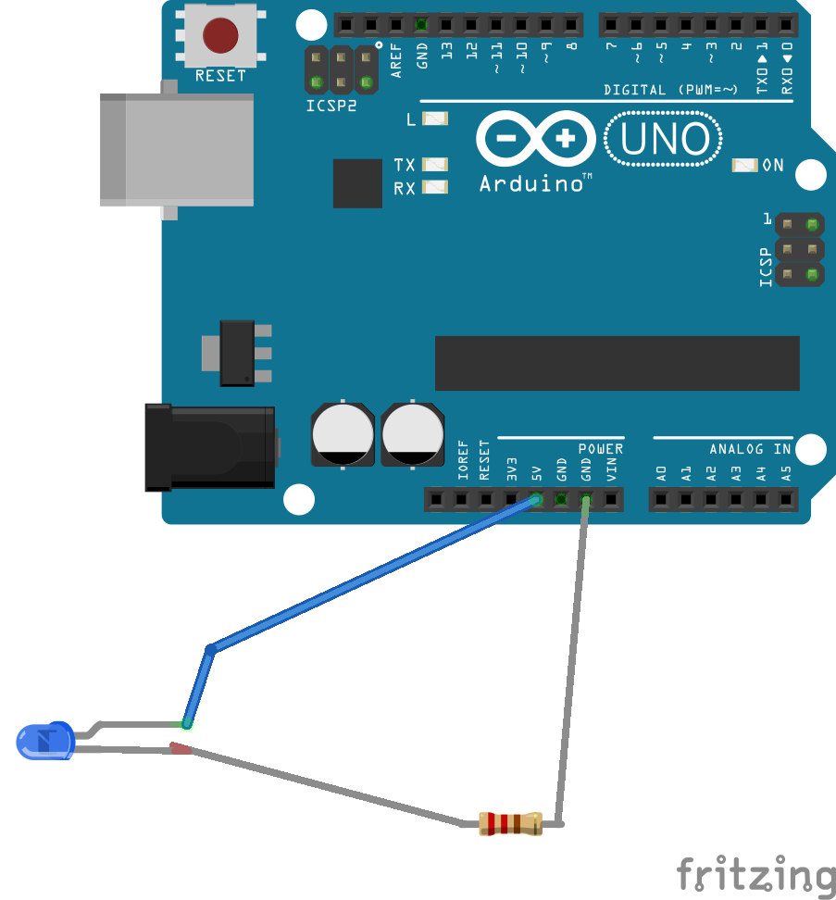

* **Data measurement and analysis method**

To analyze our data, we used **ImageJ**: for each video, we [downloaded manual tracking plugin](https://imagej.nih.gov/ij/plugins/track/track.html) and did movement tracking for each *Volvox* of each well:

The number of *Volvox* for well was not constant: this is because we couldn’t manage to control the number of *Volvox* at each pipetting, our real worry was to keep the quantity of medium constant.

All the data for each volvox/salinity has been taken for the analysis.

**Errors/Remarks during the data analysis:**

* Some parts of the videos are not very much lighted up: so it was hard to follow the Volvox when it went to these areas.
* There was a water flow (as mentioned in errors/remarks during the experiments - this is more a bias for the forces causing the movement, and not really for the data analysis). Some volvos tended to be in this “border line” created by the water.
* *Volvox* had also circular movements on themselves, we didn’t consider.
* Some tracks start at the halfway of the video, as they didn’t appear previously.

**Things that would be interesting to study:**

* The sign of phototaxis depending on the salinity concentration
* The rotation time of *Volvox*
* The changes in form of *Volvox*
* Try our same experiment but with more water, and better quality of video: light, definition.

Friday 10th February

**Study of the flagella**

After having analyzed the data, we wanted to know if salt can have an impact on flagella.

Our 2 hypothesis is that salt can modify the motility of flagella or remove it.

To know that, we need to observe the flagella at microscope with different concentration of salt.

Materials needed:

* 2 eppendorf
* 1 test tube
* 1 becher
* NaCl
* Water
* 10 cell slides
* Cover slides

For the mother solution of salt and water, we put 3 g of NaCl and 10 mL of water in a test tube. Vortex the tube. Put 200 microL of water in a eppendorf and 180 microL of water + 20 microL of the mother solution in the other.

Put in a well of the cell slides 40 microL of the Volvox media with volvox and 20 microL of the first eppendorf. Put a cover slide on it. Observe the Volvox on microscope at x400 zoom and take pictures with phone.

Do the same thing for the second eppendorf.

For the observation with the solution without salt, Volvox moved very fast so it was difficult to observe them.

We don’t manage to see flagella because of the zoom of the microscope.

1. https://en.wikipedia.org/wiki/Saline_water